Seat No:_________________ | Enrolment No:__________________

School of Computer Applications
Department of Master of Computer Applications
MCA Semester – 2 Remedial Summer - 2024 Exam

Subject Code: 140110201 | Date: 15/06/2024
Subject Name: Data Structures (DS)
Duration: 02:30 Hours | Total Marks: 50
Instructions:
1. Attempt all the questions
2. Figures on the right indicate the marks.
3. Draw the figures and give suitable examples as and where necessary.

Q - 1 | Answer The Following Questions.
 | Define: Algorithm | 1
 | What is Asymptotic Notation? | 1
 | What is Primitive data structure? | 1
 | Define and give examples of Linear and Non-Linear Data Structures. | 3
 | How to analyze algorithm efficiency? Explain Space complexity of an algorithm in detail. | 4
 | OR
5. | Explain the classification of Data Structures with example. | 4
Q - 2 | Answer The Following Questions.
 | What is condition for overflow in simple queue? | 1
 | Make a comparison between a linked list and a linear array. Which one will you prefer to use and when? | 1
 | Write any two applications of stack. | 1
 | Give the advantages and uses of a circular linked list. Write an algorithm to insert at last position with suitable diagram. | 3
 | Convert following infix expression into postfix expression using stack  (A – (B / C + (D % E * F) / G)* H)  (Show every steps in tabular format). | 4
 | OR
10. | Explain the concept of a circular queue? How is it better than a simple queue? Write an algorithm to delete element in circular queue with suitable diagram. | 4
Q - 3 | Answer The Following Questions.
 | Define : Balance Factor | 1
 | Explain any two applications of Graph. | 1
 | Define : Spanning tree. | 1
 | Create a binary search tree with the input given below: 98, 2, 48, 12, 56, 32, 4, 67, 23, 87, 23, 55, 46  (a) Insert 21, 39 and 63 into constructed tree  (b) Delete values 56, 2, and 45 from the tree | 3
 | Construct an AVL tree by inserting the following elements in the given order.  63, 9, 19, 27, 18, 108, 99, 81.  (Hint: Show every steps) | 4
 | OR
15. | Find minimum spanning tree of following graph using Kruskal’s algorithm [Consider A as a starting vertex].  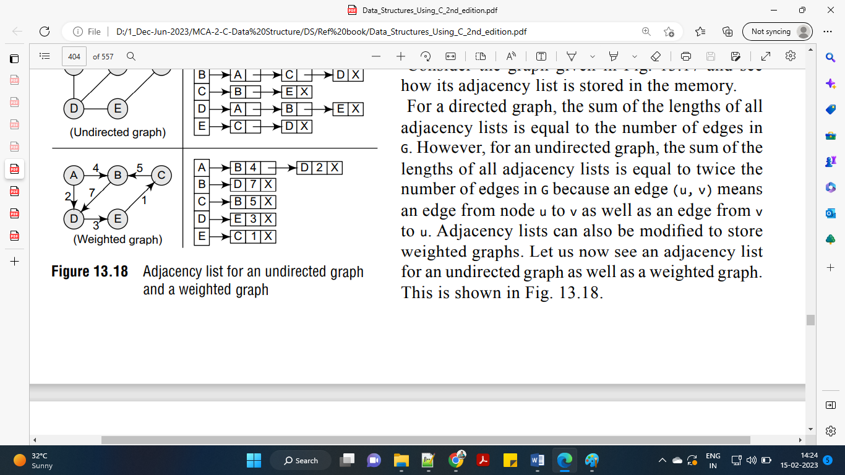 | 4
Q - 4 | Answer The Following Questions.
 | The total number of edges containing the node u is called its__________ | 1
 | What are the different types of sorting techniques? Name any two technique of sorting. | 1
 | Evaluate the following postfix expression in tabular form: 3 5 * 6 2 / + | 1
 | What is hashing? What are the qualities of a good hash function? Explain any two hash functions in detail. | 3
 | Define searching. Write an algorithm for Binary search.  OR | 4
20. | Write algorithm for Bubble sort method. | 4
Q - 5 | Answer The Following Questions.
 | What is top of stack? Why stack is called LIFO list? | 1
 | Which traversal of binary search tree gives data in sorted order? | 1
 | Define: Sibling | 1
 | Explain creation, insertion of doubly linked list with example. | 3
 | Differentiate between depth-first search and breadth-first search traversal of a graph. Find the BFS traversal for the following graph:  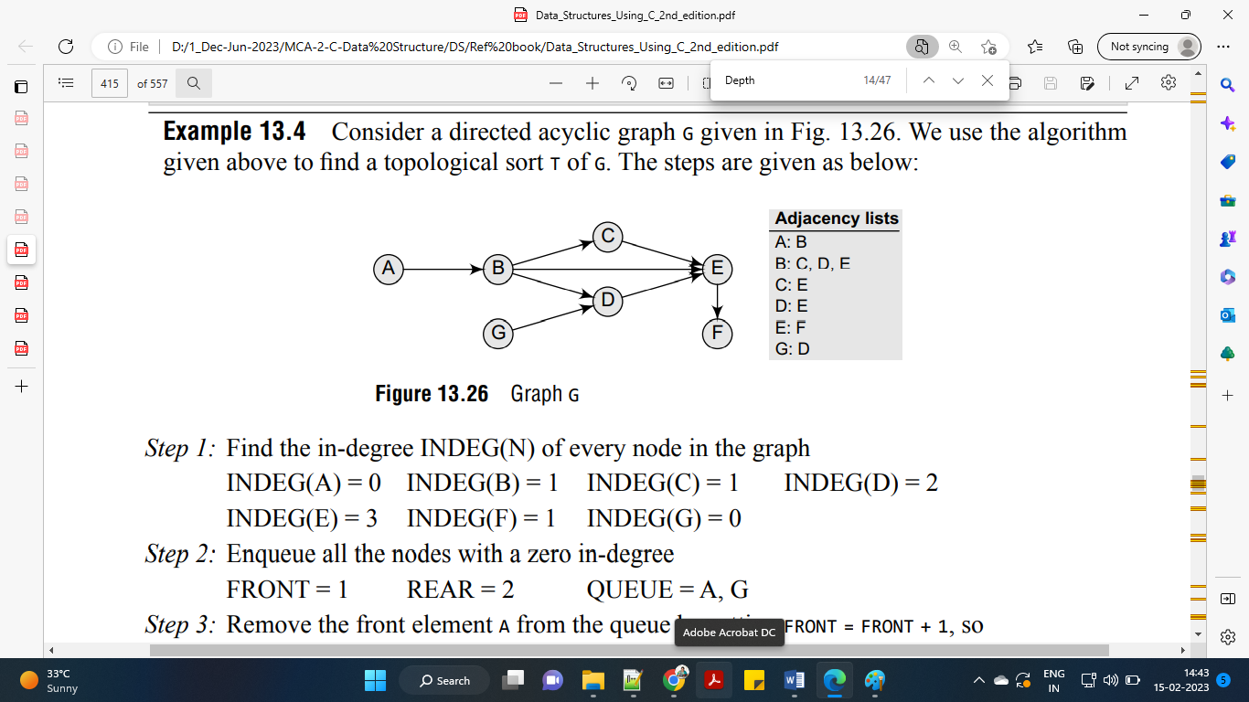 | 4
 | OR
25. | Describe Quick sort : 21, 16, 24, 18, 22, 25, 26  Hint: Show every passes, consider pivot as first element | 4

******************************************************************************************************************

